**Understanding Data Relationships in MS Access**

Introduction

In databases, relationships are like connections between different tables that help organize and link data together. Just like in real life where students are connected to courses through enrollment, databases use relationships to show how different pieces of information are related to each other.

# Types of Relationships

## One-to-One Relationship

* Definition: Each record in Table A connects to only ONE record in Table B, and vice versa.
* Real Example: Each student has only one student ID card, and each ID card belongs to only one student.
* In Our Database: If we had a separate "StudentID Cards" table where each student had exactly one ID card.

## One-to-Many Relationship

* Definition: One record in Table A can connect to MANY records in Table B, but each record in Table B connects to only ONE record in Table A.
* Real Example: One teacher can teach many students, but each student has only one main teacher.
* In Our Database:
* One course can have many enrolled students (Course= Enrollment)
* One student can enroll in many courses (Student= Enrollment)
* This is the MOST COMMON type of relationship.

## Many-to-Many Relationship

* Definition: Many records in Table A can connect to many records in Table B.
* Real Example: Students and Courses - each student can take many courses, and each course can have many students.
* In Our Database: We created this using the Enrollment table as a "junction table" between Students and Courses.

## How We Implemented Relationships in Our Student Database

In our database, we created three tables:

* **Students Table** (StudentID, Name, Email)
* **Courses Table** (CourseID, CourseName, Credits)
* **Enrollment Table** (EnrollmentID, StudentID, CourseID, Date)

## The Relationships We Made:

* Students= Enrollment (One-to-Many)
* One student can have many enrollment records
* Courses= Enrollment (One-to-Many)
* One course can have many students enrolled

*Together, this creates a Many-to-Many relationship between Students and Courses through the Enrollment table.*

## Screenshots from Our Database

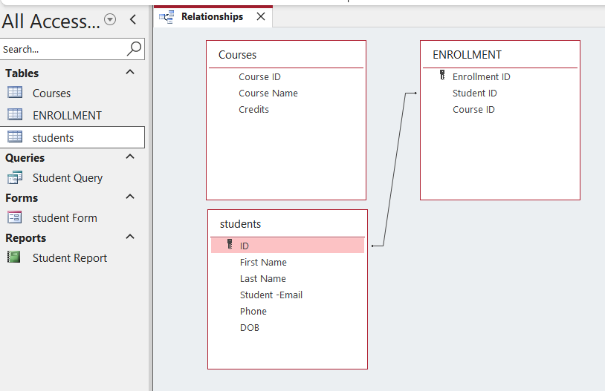

Importance of Referential Integrity

## What is Referential Integrity?

It's a rule that ensures relationships between tables remain valid. It prevents you from:

* Adding enrollment for a student that doesn't exist
* Deleting a course that has students enrolled in it

## Why It's Important:

* Prevents Orphan Records: Stops having enrollment records for students who don't exist
* Data Accuracy: Ensures all relationships make sense
* Database Consistency: Keeps the database reliable and trustworthy
* Prevents Errors: Stops invalid data from being entered

Example from Our Database:  
With referential integrity enabled:

* We CAN enroll StudentID 5 in CourseID 3 (both exist)
* We CANNOT enroll StudentID 99 in CourseID 1 (StudentID 99 doesn't exist)
* We CANNOT delete a course if students are enrolled in it

Conclusion

Understanding relationships is crucial for designing good databases. One-to-many relationships are the most common in real-world applications. Referential integrity acts like a quality checker that ensures our data remains accurate and reliable. Without these relationships, our database would be like a library without a catalog system - full of information but impossible to find meaningful connections.